File Permission Task
- Launched a EC2 instance and connected directly and ran as root user first and then created a file demo.txt in the Home Directory and then changed the file permission
And now the file has the (7 = rwx, 6 = rw-, 4 = r--)
Owner: read, write, execute
Group: read, write
Others: read only
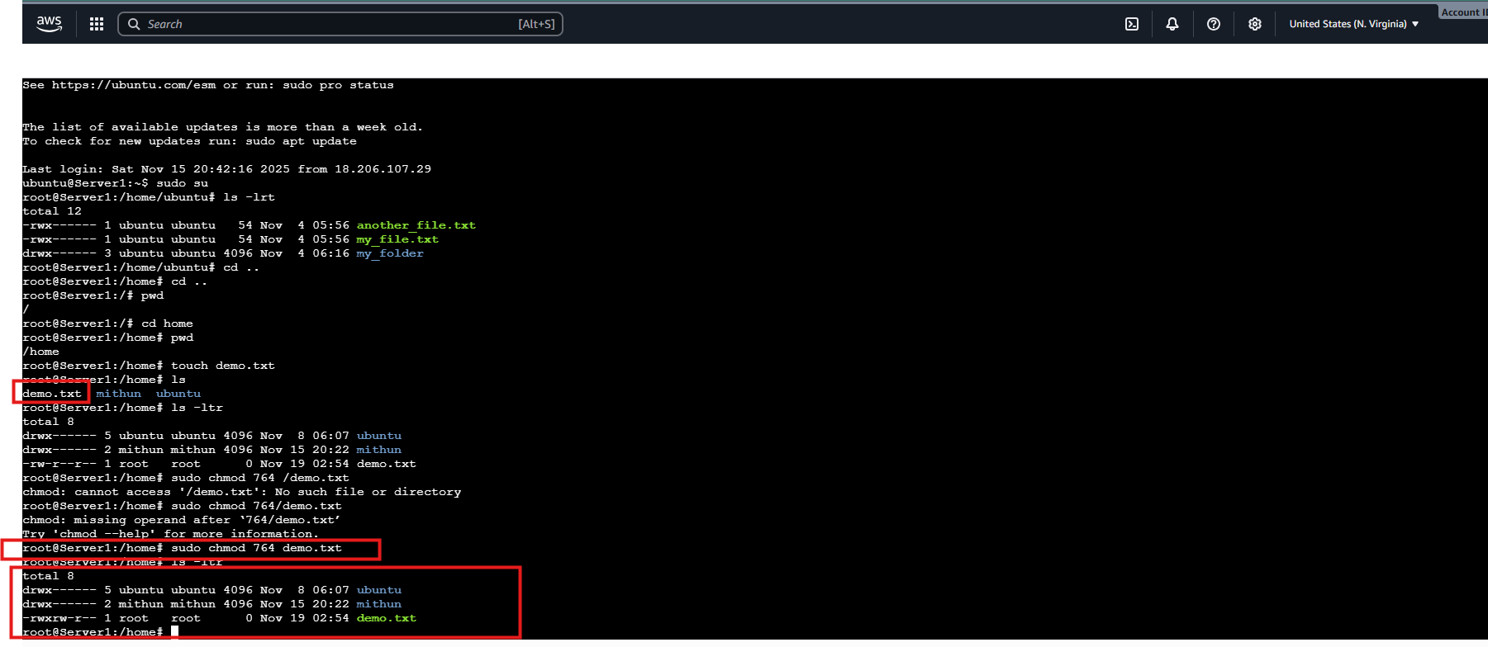

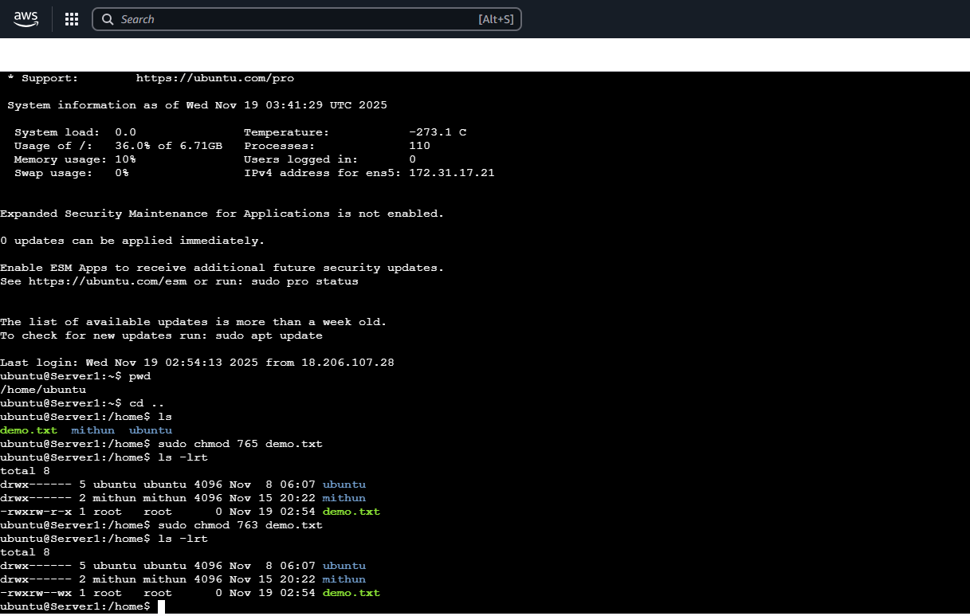
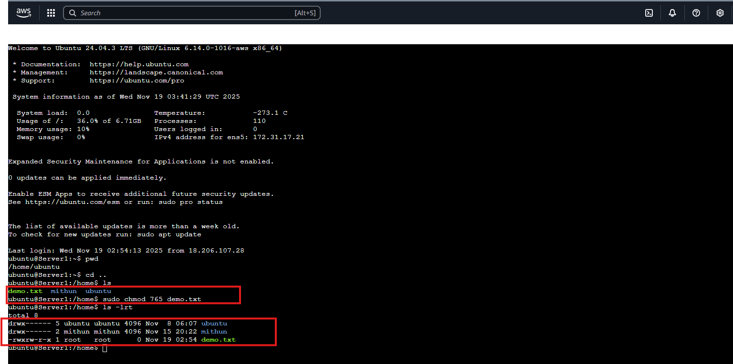
- No the file permission has changed to execute and any users can execute this file and all the users has the file permission to read, write and execute.

